**SC531 PROBABILITY & RANDOM VARIABLES**

**Quiz #05**

**Maximum marks: 12. Time allowed: 40 minutes.**

Q-1 Planes at an airport arrive at the average rate of 5 arrivals per hour, and the arrivals define a Poisson process. What is the probability that the time between two successive arrivals is less than M minutes?

**🡪 1 – exp-M/12**

**Straight application of the pdf of inter-arrival time, integrated from 0 to M, the average rate being 1/12 arrivals per minute**

Q-2 Recall the Markov process defined as "random walk with reflecting barriers". The four states of the process are 1, 2, 3 and 4. The transition probability matrix is as given below, with a = M/10. The initial probability distribution over states is (1/4, 1/4, 1/4, 1/4). What is the probability that the process is in state 2 after one time step?

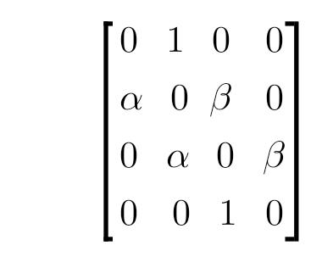**🡪 0.25 + M/40**

**Pre-multiply COLUMN 2 of above matrix with the initial probability matrix.**

Q-3 We need to simulate TEN tosses of a biased coin with Prob(HEAD) = M/10. For this purpose, the random number generator function rand() is used, which generates these ten random numbers: { 0.48746, 0.68788, 0.66541, 0.46018, 0.11471, 0.71530, 0.48320, 0.37155, 0.62342, 0.91954 }. How many simulated tosses of the coin will show HEAD?

**🡪 Answer: Count of random numbers in given list which are < M/10.**

Q-4 Customers arrive at a bank at the rate of M per minute, and are serviced at the rate of 10 per minute. If the process defines a Poisson queue, what is the average number of customers in the bank?

**🡪 [M/10] / [1 – M/10]**

**Straight application of relevant formula for Poisson queue.**